1.Remove Element:
#code:
class Solution {
public int removeElement(int[] nums, int val) {
int k = 0;
for (int i = 0; i < nums.length; i++) {
if (nums[i] != val) {
nums[k] = nums[i];
k++;
}
}
return k;
}
}
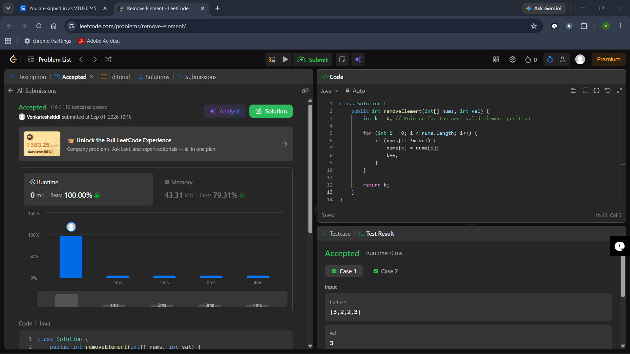

2. Remove Duplicates from Sorted Array:
#code:
class Solution {
public int removeDuplicates(int[] nums) {
if (nums.length == 0) return 0;
int writeIndex = 0; // Points to the last discovered unique element
for (int i = 1; i < nums.length; i++) {
if (nums[i] != nums[writeIndex]) {
writeIndex++;
nums[writeIndex] = nums[i];
}
}
return writeIndex + 1;
}
}
